Tire Pressure Threshold
Notes
- Make sure to enable data logging and connect/backup to Google Drive
- 2018 Trucks need security bypass cable

Procedure
Key in RUN position
Open App
Connect to OBD II device
Select DODGE RAM 1500 or 2500 or 3500
From drop down menu select BODY COMPUTER
- MY2013-17 POWERNET (2018)
- CONNECT
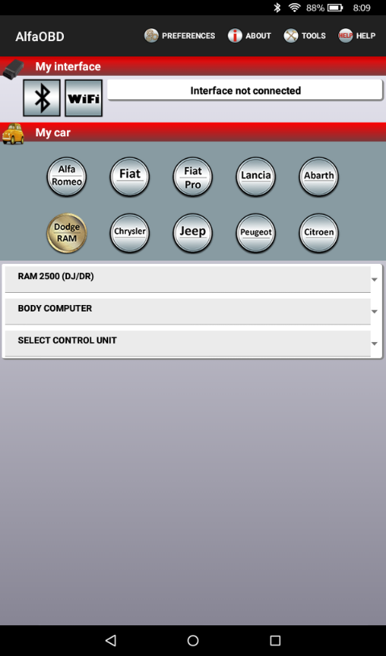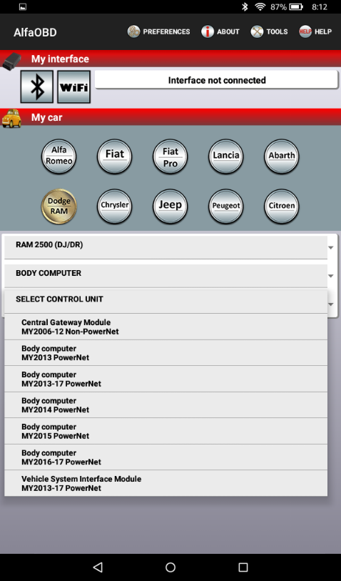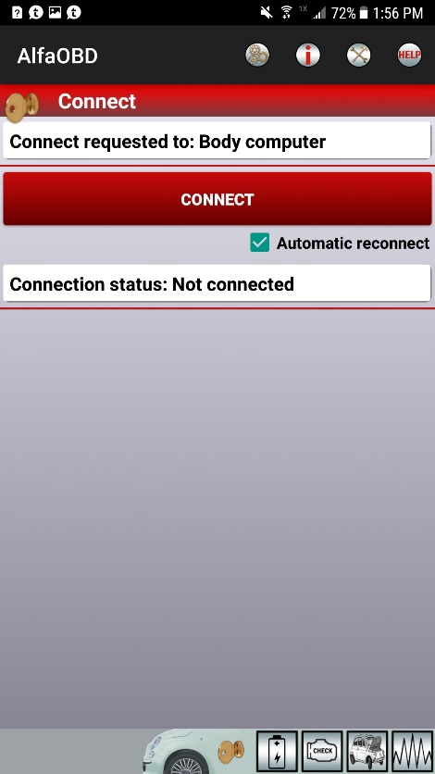
Click on the CAR WITH THE OPEN HOOD (Active Diagnostics)

Click SELECT PROCEDURE TO START > Select UPDATE PRESSURE THRESHOLDS
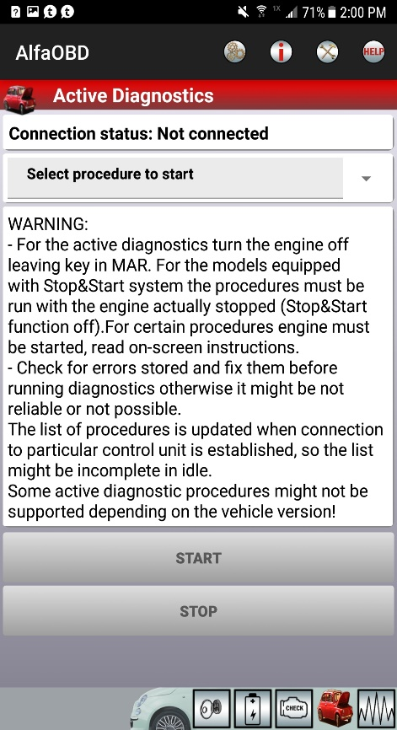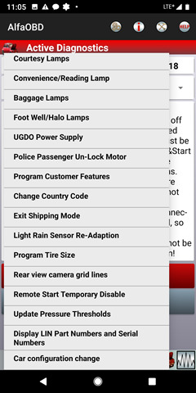
Select STATUS PRESSURE FRONT/REAR
- Select desired pressure for front and rear
- START
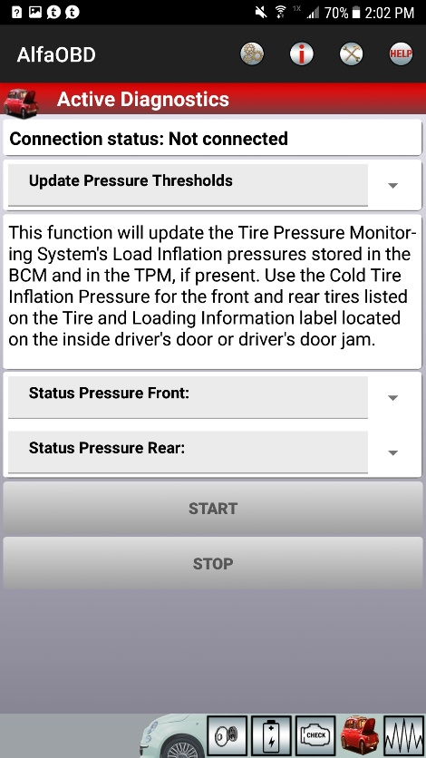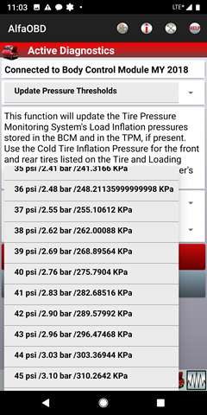

Exit BODY COMPUTER screen back to main screen
Select RADIO FREQUENCY HUB (RFH)
Press SELECT CONTROL UNIT
- From drop down menu select RADIO FREQUENCY HUB
- CONNECT
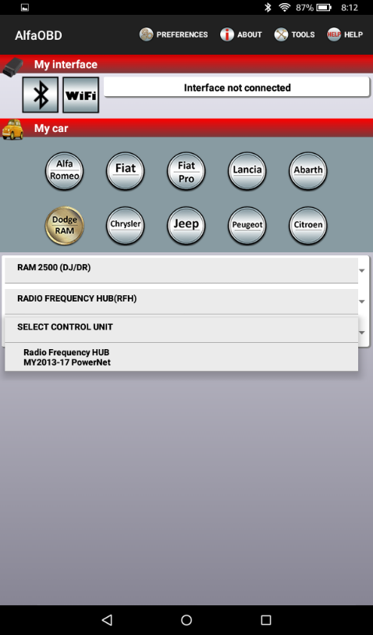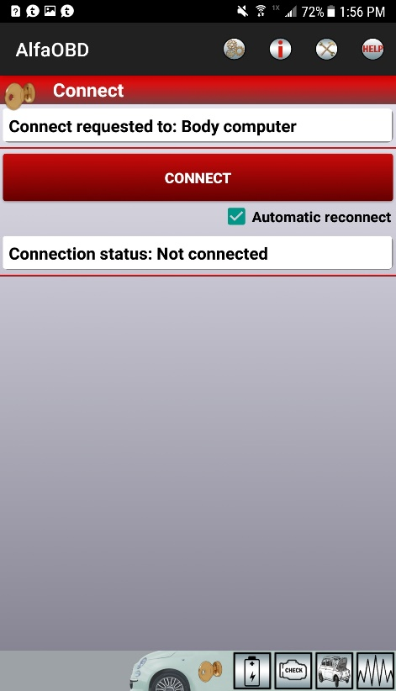
Click on the CAR WITH THE HOOD OPEN
Read instructions Click on SELECT PROCEDURE TO START > Select RF-HUB RESET/REPLACE
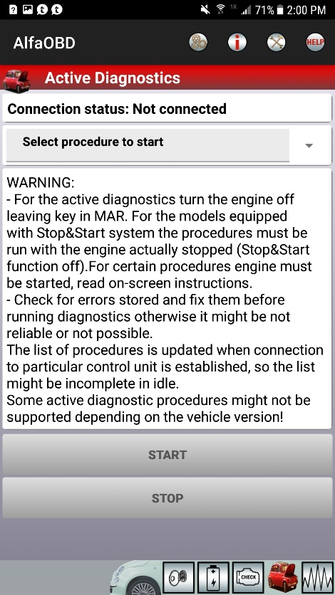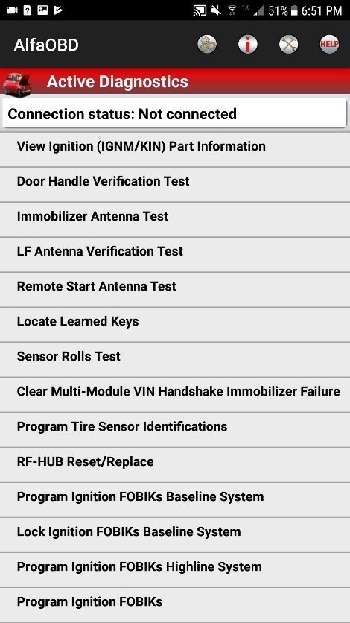
Enter 4 Digit PIN > Select START
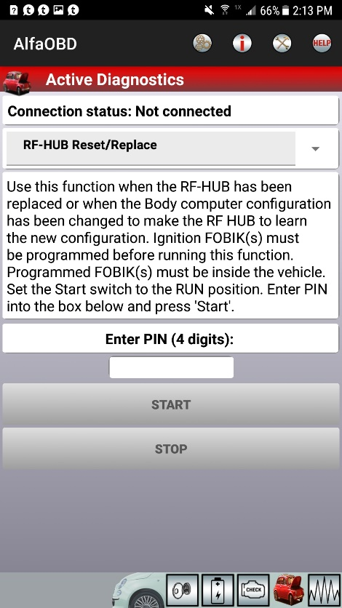

Screen should say PROCEDURE COMPLETE, shut vehicle off, open/close door and wait a minute

