Tire Size
Notes
- Make sure to enable data logging and connect/backup to Google Drive
- 2018 Trucks need security bypass cable
- Tire size is stored in the BCM
- Tire size must match in BCM and ABS settings
- Run ABS Initialization in ABS diagnostic after size change
Procedure
Key in RUN position
Open App
Connect to OBD II device
Select DODGE RAM 1500 or 2500 or 3500
From drop down menu select BODY COMPUTER
- MY2013-17 (2018)
- CONNECT
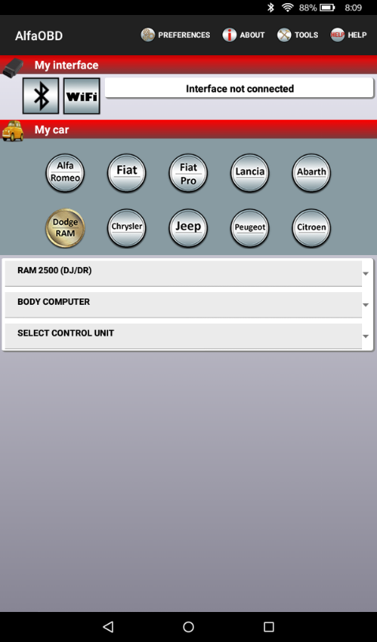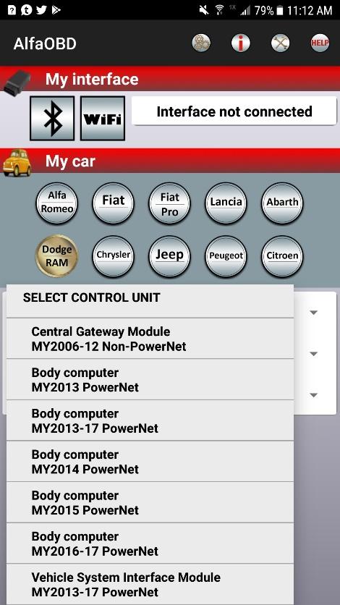

Click on the CAR WITH THE OPEN HOOD
From the drop down menu select PROGRAM TIRE SIZE
  - From here you can either choose from a selected list of tire sizes or enter your own in MM (circumference)
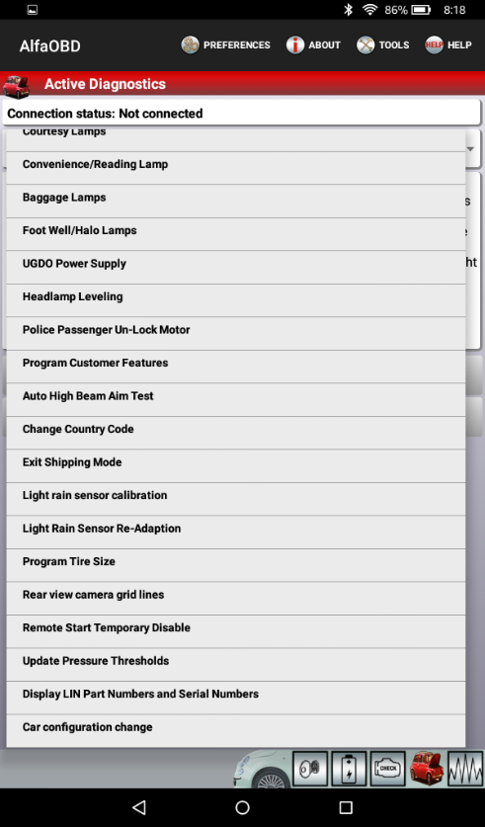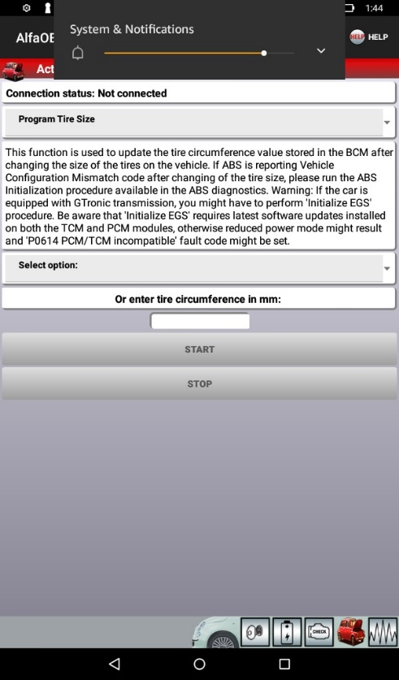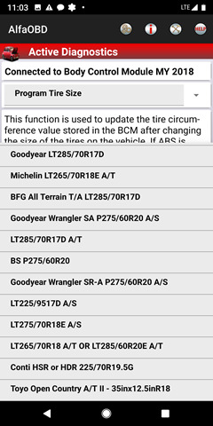
Press START
Once complete, back out to the main page
Cycle the key (OFF wait 1 MIN, RUN)
Now your instrument cluster should be lit up.
Go back into CAR CONFIGURATION CHANGE > Select VEHCONFIG 4- DYNAMIC TIRE CIRCUMFERENCE (ALL OR REAR)
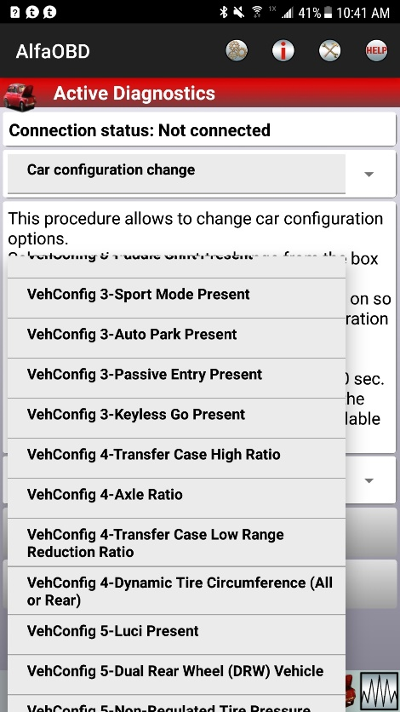 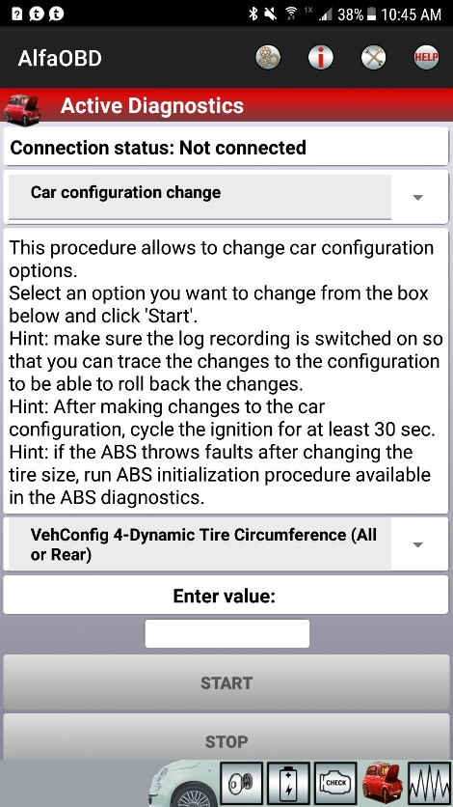 Enter value and select START

ABS MODULE RESET
Select DODGE RAM 1500 or 2500 or 3500
From drop down menu select ABS
- ABS ATE/CONTINENTAL
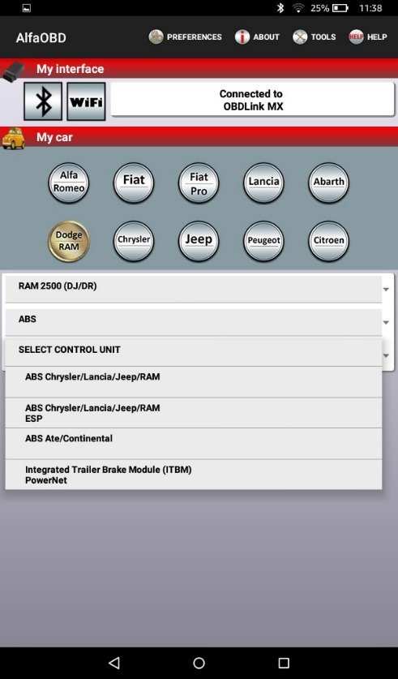
Click on the CAR WITH THE HOOD OPEN
From the drop down list select STATIC ECU INITIALIZATION Click on CHECK ENGINE icon
>Read the instructions and hit START > CLEAR FAULTS
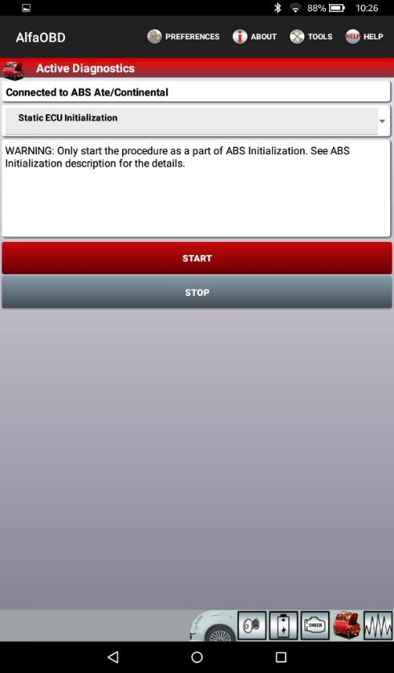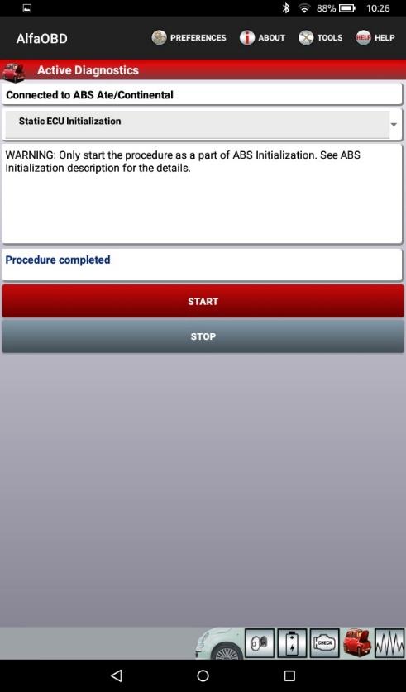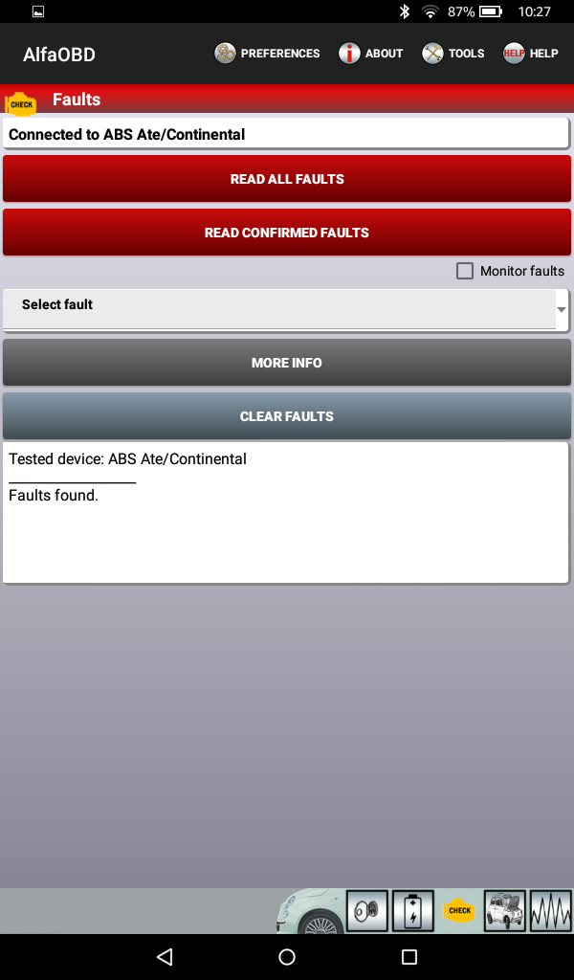
CYCLE KEY (OFF, RUN)
Click CAR ICON
From drop down menu select CLEARING ROLLS INFORMATION
- START
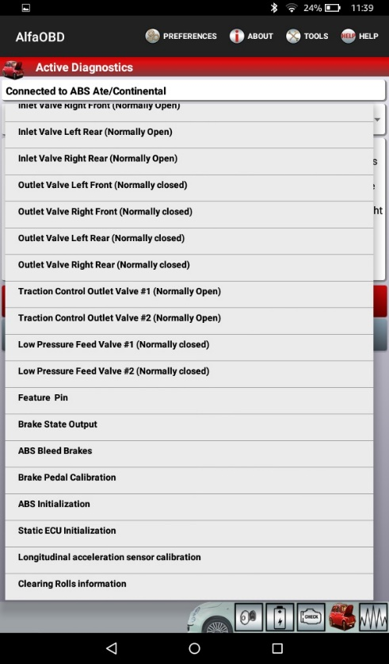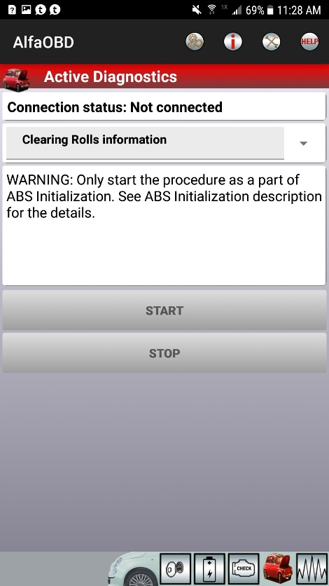
Clear faults in BODY CONTROL MODULE > Clear faults in ENGINE
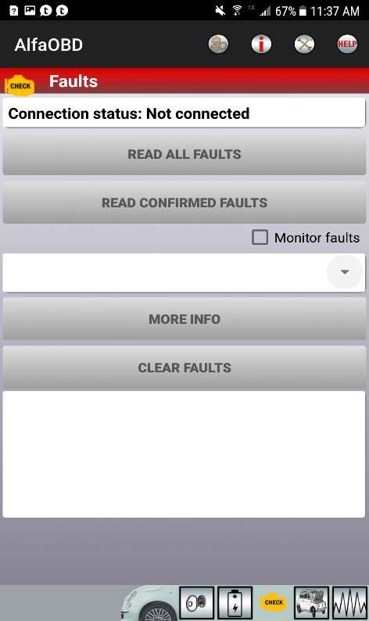
CYCLE KEY (OFF, RUN)
EXIT program and check speed with GPS
Note
You May have to select ENGINE > Select MY CHRYSLER PENISTAR 3.6/4.7/5.7/6.4 HEMI> Select the CHECK ENGINE Icon and clear any codes

